Adv. Algebra 2 Name: ____________________
Unit 3 Review: Systems of equations

Solve each system of equations.

1.
$5x-y=-7z+16$
$x+y-2z=-5$
$-2y+14z=-10x+8$

2.
$x+6z=5$
$3x+y-4z=-3$
$2x-y-2z=-8$

3.
$-2z=9-x-y$
$4x-y-2z=8$
$4x+4z=-y-6$

4.
$x+y+z=8$
$3x-y+4z=25$
$6x-2y+8z=50$

5.
$4x-y-z=27$
$x-y+2z=-3$
$2x+y-2z=21$

6.
$x+4y+3z=-3$
$x=4y+z+9$
$2x+4y=-z-3$
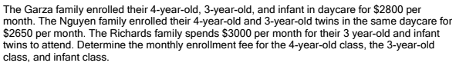
For each problem (7-12), write a system of equations, solve the system, write your answers in context.
7.

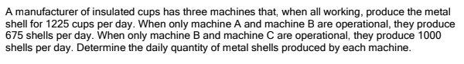
8.

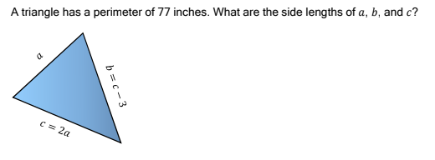
9.

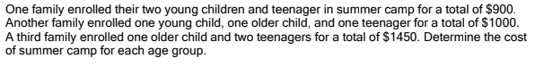
10.

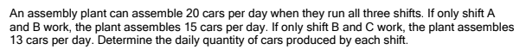
11.

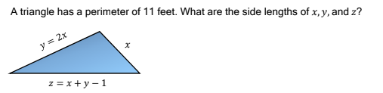
12.

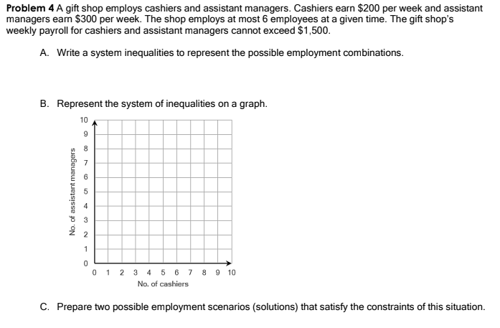
13.

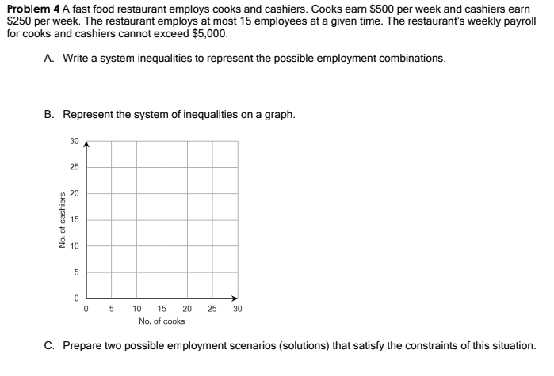
14.

